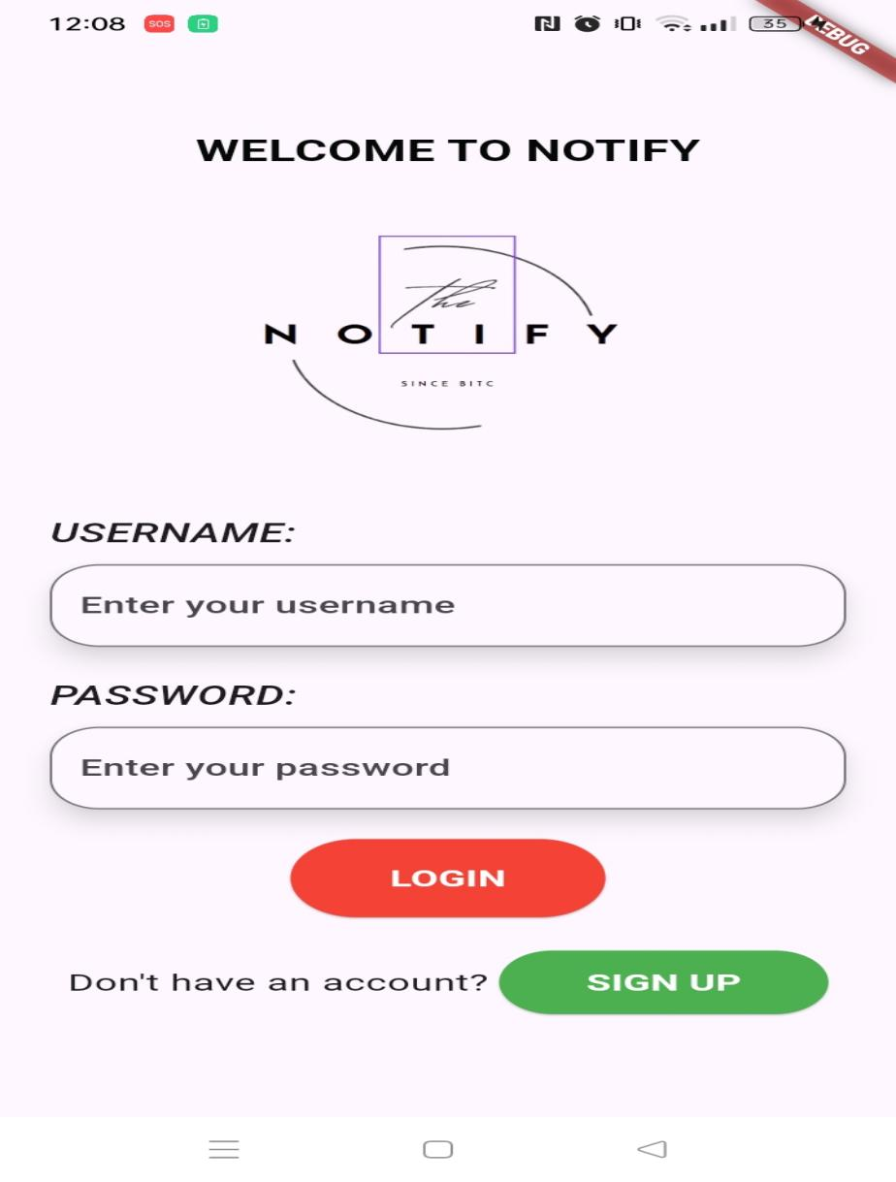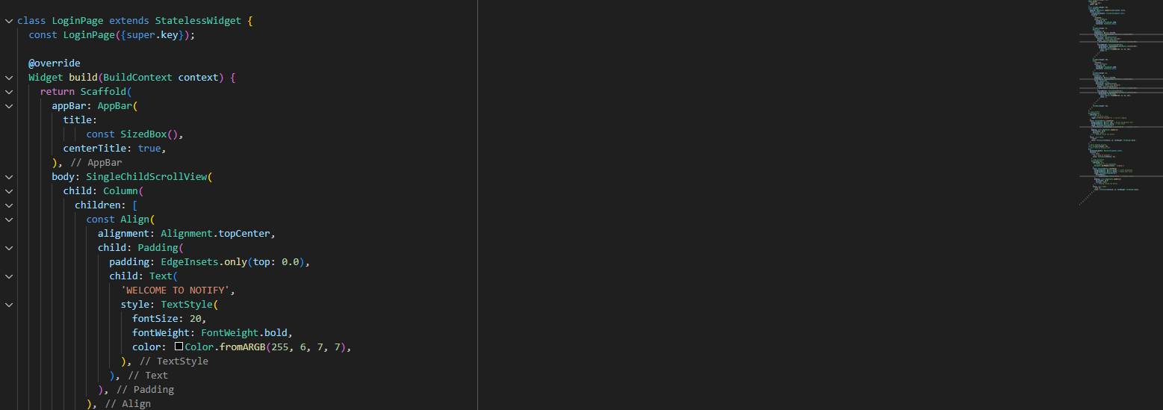USING WIDGET  
  
  
  
  
  
  
  
  
  
  
  
  
  
  
  
  
  
  
MY APP WITH THE WIDGET OF TEXT AND THE TEXBOXES

